EXPERIMENT – 5 DESIGN AND SIMULATION OF UJT RELAXATION OSCILLATOR USING LTSPICE
EXPERIMENT – 5.1 FREQUENCY ANALYSIS OF UJT RELAXATION OSCILLATOR USING LTSPICE
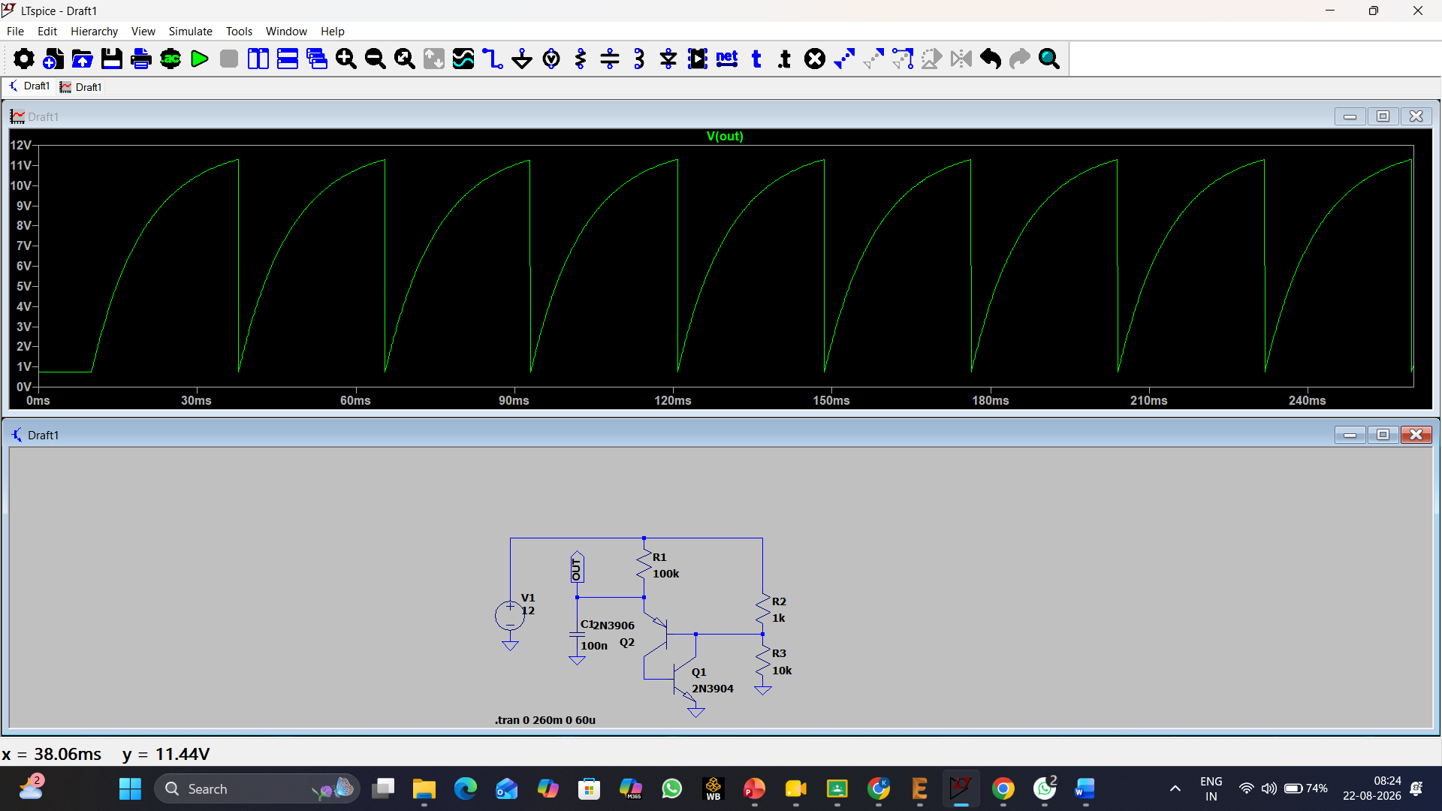

EXPERIMENT – 5.2 BANDWIDTH ANALYSIS OF UJT RELAXATION OSCILLATOR USING LTSPICE
Waveform | Observation
Amplitude | 11.4V
Time period | 38.06ms
Frequency | 26.27 Hz
Band width | 11.16 Hz

EXPERIMENT – 5.3 WAVEFORM ANALYSIS OF UJT RELAXATION OSCILLATOR WITH DUTY CYCLE USING LTSPICE
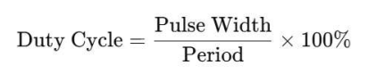
Duty cycle = $\frac{27.69}{38.06}*100=72.75\%$

